Data Analysis Project Report

European Housing Market Analysis

1. Executive Summary
This project analyses the Eurostat House Price Index (HPI) dataset containing quarterly housing price indices across European Union member states and selected European countries.
The HPI measures the price changes of all residential properties purchased by households (flats, detached houses, terraced houses, etc.), both newly built and existing.
The objectives of this analysis are :
- Examine long-term housing price trends and short-term market dynamics
- Evaluate country-level growth trends
- Time-series analysis using quarterly and annual percentage changes
- Identify high-growth and high-volatility markets through statistical analysis

Key Highlights :
- House prices up by 5.1% in the Euro area and up by 5.5% in the European Union in Q3 2025, compared with the same quarter of 2024.
- Highest Annual House Price Increase
  - Country : Türkiye
  - Period : Q3 2022
  - Annual Growth : 180.5%
Indicates extremely high inflation and strong housing demand.
- Largest Annual House Price Decline
  - Country : Luxembourg
  - Period : Q4 2023
  - Annual Growth : –14.5%
Reflects a significant housing market correction.

2. Dataset Overview :
- The dataset covers 2015–2025 housing price trends
- Includes 33 European countries and regional aggregates
- Total records analysed: 1,419 quarterly observations
- Metrics include:
  - Price Index
  - Quarterly Rate of Change
  - Annual Rate of Change

Price Index (2015 = 100) Time frequency: Quarterly
- Base year = 2015
- Value 100 → price level in 2015
- 120 → 20% higher than 2015
- 90 → 10% lower than 2015

source: https://ec.europa.eu/eurostat/databrowser/view/teicp270/default/table?lang=en&category=t_prc.t_prc_hps

3. Trend Analysis :
The trend analysis of the HPI from 2015 to 2025 reveals significant changes in housing price dynamics across European countries over time.

Housing Price Trend - Time Series Analysis
Euro area and EU - Annual rate of change 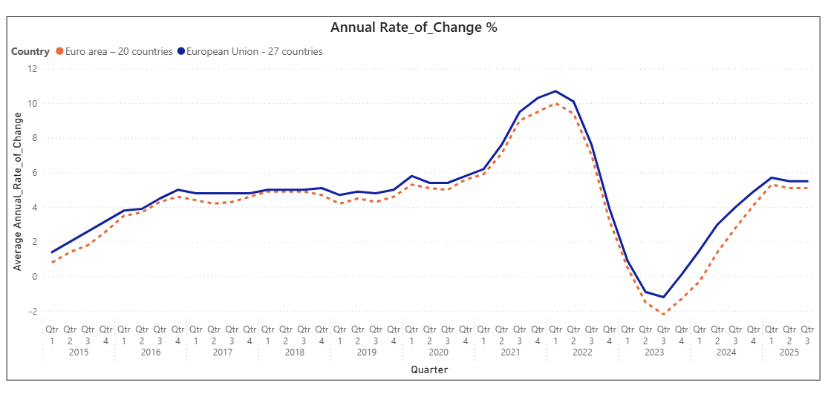
Euro area and EU - Price Index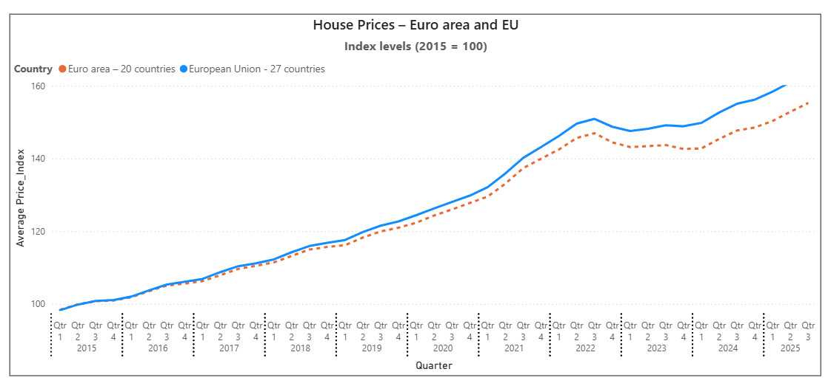

Key Observations:
Both time series show a clear upward long-term housing price trend.
- Phase 1 – Stable Growth (2015–2019)
Stable upward trend with low volatility

- Phase 2 – Housing Boom (2020–2022)
This period represents the strongest housing boom in the time series.
Housing prices accelerated significantly during this period

- Phase 3 – Market Correction (2023)
This represents a cyclical downturn in the time series.
Price growth slowed significantly.

- Phase 4 – Recovery Phase (2024–2025)
Growth returned gradually.

- Housing prices in both regions move almost simultaneously.
- Housing markets stabilized and returned to moderate growth.
- The latest data suggests the EU housing market is returning to sustainable growth levels.

4. Latest Market Trends (2025)

- Fastest Growing Housing Markets
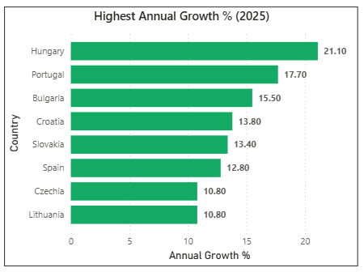
Seven countries recorded increases of more than 10% recording the strongest growth.
These countries show strong housing demand and price momentum.

- Weak or Declining Markets

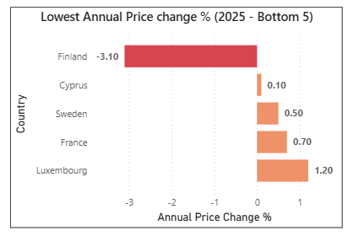
These markets indicate slow growth.
Finland was the only country to record a significant price decline in 2025.

Top 5 Countries by Latest Housing Price Index (2025 Q3)
Based on the most recent available data:
Rank | Country | Price Index
1 | Hungary | 375.19
2 | Portugal | 269.35
3 | Iceland | 265.13
4 | Lithuania | 262.01
5 | Bulgaria | 256.01

Insights:
- Hungary stands out significantly, with a much higher index value than other countries.
- Several Central and Eastern European countries dominate the top rankings.
- This suggests stronger relative housing price growth compared to Western European countries.

5. Case Study: Hungary Housing Market
Hungary demonstrates one of the strongest housing price increases in the dataset.
The Country recorded some of the highest annual housing price increases in the European Union in 2025.
Quarter | Annual Price Change
Q1 2025 | 17%
Q2 2025 | 18.7%
Q3 2025 | 21.1%

Trend Characteristics:
- Strong upward momentum over time
- Acceleration phase in later quarters
- No major corrections observed
- Steep growth in the final observed period
- Hungary's housing market appears to be in a high-growth phase compared to the EU average.
- Strong demand, government housing policies, rising incomes, and limited housing supply have contributed to significant price growth.

6. Conclusion and Key Insights
The Eurostat Housing Price Index data reveals:
- A persistent upward trend in EU housing prices
- Significant differences across countries
- Increased price volatility in some markets
- A growing gap between high-demand and low-demand regions

Recent data for 2025 suggests that housing price growth remains strong in parts of Eastern and Southern Europe, including countries such as Hungary and Portugal, where annual price growth continues to exceed many other European markets. Meanwhile, Northern European countries such as Finland and Sweden show slower growth or mild declines, suggesting cooling housing demand.

- Volatility in the housing market

- Highest Quarterly Increase: The country of Türkiye saw the largest surge in housing market values during Q2 2022, with a notable growth of 47.1%.

- Largest Quarterly Decline: Conversely, Cyprus experienced the largest decline in housing prices in Q1 2021, with a drop of –8.4%.

These contrasting trends highlight the unpredictability of the real estate market, where periods of rapid growth can be followed by significant declines.

Strategic Insights for Investors

High-Growth Markets

Best potential returns:

Hungary

Portugal

Bulgaria

Croatia

Stable Long-Term Markets

Lower volatility:

France

Germany

Netherlands

Overall, the European housing market experienced steady growth from 2015 to 2019, followed by accelerated price increases during 2020–2022. This surge was largely driven by low interest rates, increased housing demand, and post-pandemic economic conditions. However, from 2023 onward, several markets began to slow down or correct as interest rates rose and economic uncertainty increased.
Future housing market developments will depend on economic growth, interest rate conditions, housing supply, and demographic demand across EU member states.

